Peter Zhang

(240) 994-2204

[petejzh@gmail.com](mailto:petejzh@gmail.com)

December 23, 2020

Dear Hiring Manager,

I am writing express my interest in a software engineering internship with the Prisma Access team. I am a Computer Science student at UC Berkeley with an interest in high-impact, quantitative projects. I believe that my technical and interpersonal skills align with the needs of the team.

Last Spring, I interned at the National Cancer Institute with the goal of converting an antiquated web-based data analysis tool to an updated, desktop application. When the team struggled to get permission for me to access the data, I chose instead to scrape the dataset from the website and reformat the database for efficiency. Over the following two months, I built the app with R and Electron, meeting regularly with the team for feedback and testing. The experience gives me a background in database management, cloud platforms, and software development.

Last summer, I assisted the development an online cost-benefit analysis tool at the National Institute of Standards and Technology. To guide users, I wrote a case study of wildfire-resistant retrofitting for a vulnerable community in California. I bug-tested the software and worked with reviewers to publish a 20-page user manual. The research and writing process taught me effective communication, adaptation, and attention to detail.

I currently work as a part-time debate coach at The Bronx High School of Science. In weekly practices and one-on-one drills, I give students the knowledge and confidence succeed in Lincoln-Douglas debate. Since beginning in August, I endeavored to inspire passion and discipline in the team, ultimately helping multiple students achieve success at national tournaments. I plan to bring the same empathy, patience, and persistence to my work this summer.

I draw on numerous technical experiences to contribute thorough and creative work in a timely manner and I excel in team projects by coordinating and empathizing with co-workers. I am fully confident that my passion and skillset fit perfectly with the goals of the Prisma Access team and I am excited to learn more. Please do not hesitate to contact me for questions or additional materials. Thank you in advance for your time and consideration.

Sincerely,

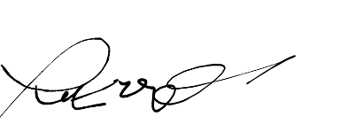

Peter Zhang